SPIRIt CARDS

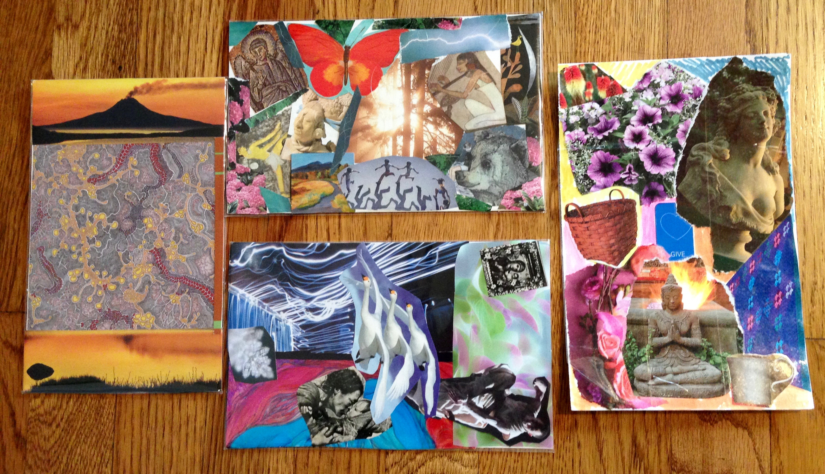

A Sacred & PlayFul monthly Workshop
of INSIGHTFUL imagery
with Rev. Suzanne Grace

The 2nd Friday of every month
10:00 – Noon
1/12, 2/9, 3/9, 4/13 2018
(By donation)
Foothill Center for Spiritual living/Auburn

Beginning with a meditation & intention to open to the Creative Spirit within, we cut & paste images from magazines and art books, creating unique individual collage cards, then do a process of opening to the wisdom of the card & discovering an affirmative blessing
from our creation!

Jump in and reserve your spot!

530-488-0620 suzanne@graceyoga.com

www.graceyoga.com
Inner Evolution ~ Outer Transformation
SPIRIt CARDS
A PlayFul & Sacred Workshop of INSIGHTFUL imagery
with Rev. Suzanne Grace

The 2nd Friday of every Month
10:00 – Noon
1/12, 2/9, 3/9, 4/13 2018
(By Donation)
Foothill Center for Spiritual living/Auburn

Beginning with a meditation & intention to open to the Creative Spirit within, we cut & paste images from magazines and art books, creating unique individual collage cards, then do a process of opening to the wisdom of the card & discovering an affirmative blessing from our creation!

Jump in and reserve your spot!

530-488-0620 suzanne@graceyoga.com

SPIRIt CARDS
A PlayFul & Sacred Workshop of INSIGHTFUL imagery
with Rev. Suzanne Grace

The 2nd Friday of every Month
10:00 – Noon
1/12, 2/9, 3/9, 4/13 2018
(By Donation)
Foothill Center for Spiritual living/Auburn

Beginning with a sweet meditation & intention to open to the Creative Spirit within, we cut & paste images from magazines and art books, creating unique individual collage cards, then do a process of opening to the wisdom of the card & discovering an affirmative blessing from our creation!

Jump in and reserve your spot!

530-488-0620 suzanne@graceyoga.com

